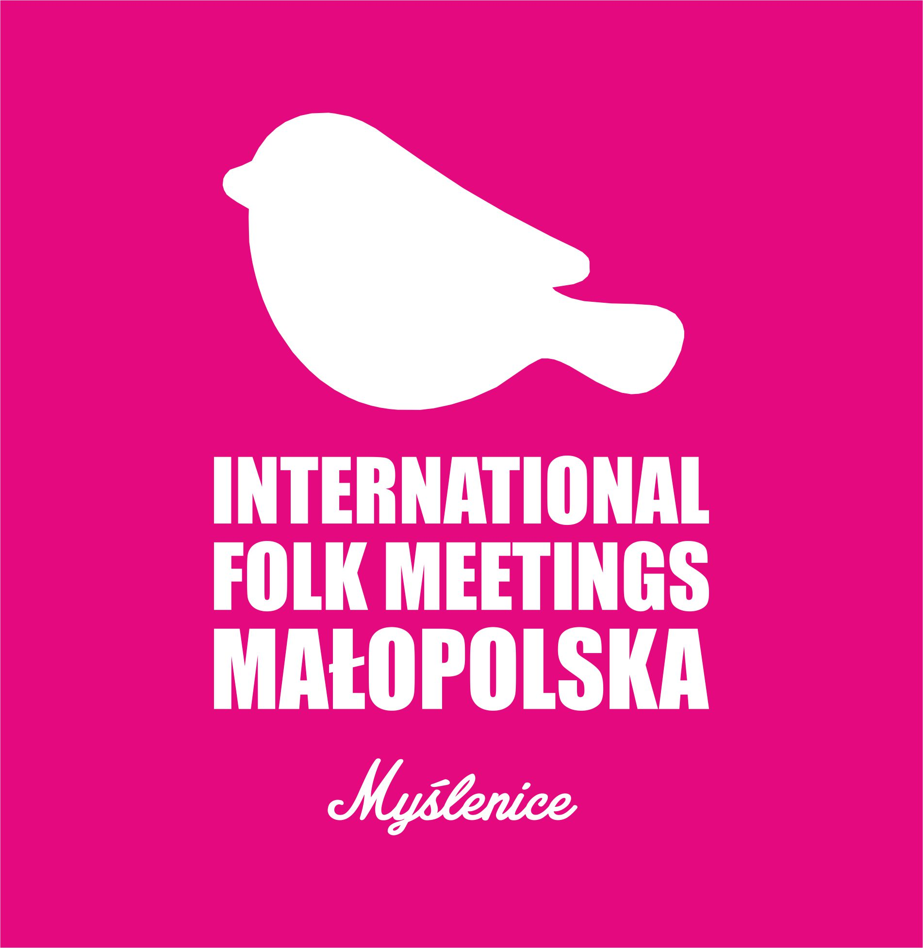

Registration Form
GROUP INFORMATION
Group Name
Country
Group Leader  - Contact Information  - Number of Dancers  - Number of Musicians  - Number of Director of official | - Tel :  - Fax :  - Email :  - Website :  - Address :  - Male : _______ persons  - Female : _______ persons  - Male : _______ persons  - Female : _______ persons  - Male : _______ persons  - Female : _______ persons
Language Use | English Only

PERFORMANCE INFORMATION
Number of Performances | - Dance :  - Music :  - Others :
Equipment Needed | - Microphone :  - Chair :  (for musician and dancer)

DEPARTURE and ARRIVAL INFORMATION
Arrival Date and Time
(John Paul II International Airport Kraków–Balice.)
Airline Flights Number | - Departure :  - Arrival :
Departure Date and Time

OTHER INFORMATIONS
Religion | please check (√) ; could be more than one religion
  Christian
  Judaism
  Buddhism
  Catholic
  Orthodox
  Hinduism
  Moslem
Religion Custom Need in Daily Life’s
Foods
Food Allergy
Others (Religion Purpose)
Along with the Registration Form, the candidates should also provide the following materials to the festival host:
- short CV of the ensemble in English (max 1000 symbols including space characters);
- high quality color pictures or slides of the ensemble for the catalogue (CMYK, 300dpi resolution; min 15 x 15 cm; formats - TIFF, EPS, JPG, PNG);
- recent video recordings (DVD, format as AVI, MPEG4, DIVX, YOUTUBE) with ensemble’s performance not shorter than 15 minutes.
The due date for the complete application is March 18, 2024

